Frank Smith
November 27, 1867 – February 21, 1950

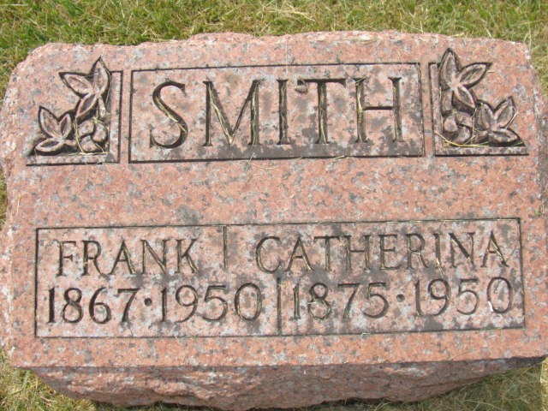
Photo by Alicia Kneuss

Frank Smith
in the Indiana, U.S., Death Certificates, 1899-2017
Name Frank Smith
Gender Male
Race White
Marital Status Married
Age 82
Birth Date 27 Nov 1867
Birth Place Cervi, Indiana
Death Date 21 Feb 1950
Death Place Decatur, Adams, Indiana, USA
Death Registration Date 1950
Father Samuel Smith
Mother Harriet Egbert
Informant Mrs. Katie Smith; Decatur, Indiana
Burial February 24, 1950; Maplewood Cemetery; Decatur, Indiana

