Florence I. (Reidenbach) Smith
November 20, 1918 – May 25, 1994

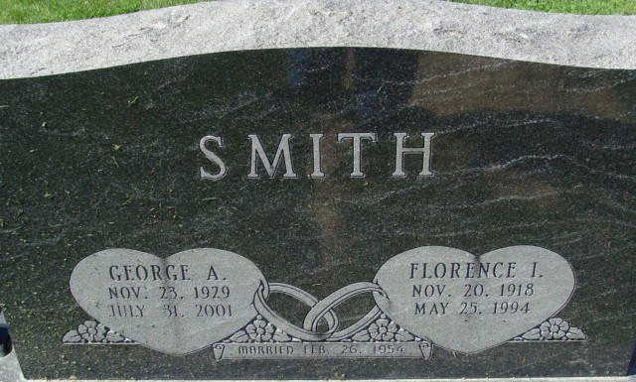
Photo by Alicia Kneuss

Florence I. Reidenbach from tree BUELONG2
Spouse George Anthony Smith
Father Wilbur Lewis Reidenbach
Mother Adeline Sophia Bischoff
Birth 20 Nov 1918 Van Wert, Ohio, USA
Death 25 May 1994 Decatur, Adams, Indiana, USA
Residence 1935 Decatur, Adams, Indiana, USA

