Ethel (Hale) Smith
September 14, 1870 – February 6, 1936

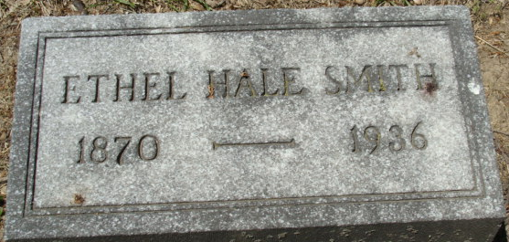
Photo by Alicia Kneuss

Ethel Hale Smith
in the Indiana, U.S., Death Certificates, 1899-2017
Name Ethel Hale Smith
[Ethel Hale Hale]
Gender Female
Race White
Marital Status Married
Age 65
Birth Date 14 Sep 1870
Birth Place Bluffton, Indiana
Death Date 6 Feb 1936
Death Place Fort Wayne, Allen, Indiana, USA
Death Registration Date 1936
Father John D Hale
Mother Caroline Holmes
Spouse David E Smith
Informant Judge David E. Smith
Burial February 9, 1936; Decatur, Indiana

