Esther S. (Swenson) Smith
October 28, 1924 – January 20, 1979

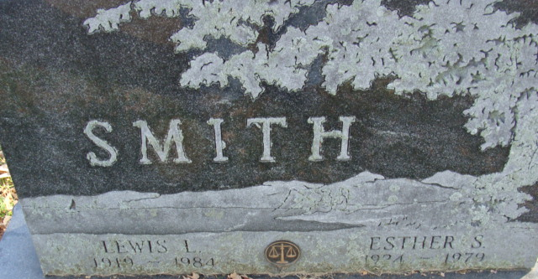
Photo by Alicia Kneuss

Esther S Smith
in the Indiana, U.S., Death Certificates, 1899-2017
Name Esther S Smith
[Esther S Swenson]
Gender Female
Race White
Marital Status Married
Age 54
Birth Date 28 Oct 1924
Birth Place Wisconsin
Death Date 20 Jan 1979
Death Place Fort Wayne, Allen, Indiana, USA
Death Registration Date 1979
Father Albert Swenson
Mother Eleanor Petersen
Spouse Lewis Lutz Smith
Informant Lewis Lutz Smith; Decatur, Indiana
Burial January 24, 1979; Decatur Cemetery; Decatur, Indiana

