Elmer Daniel Smith
October 4, 1868 – May 31, 1952

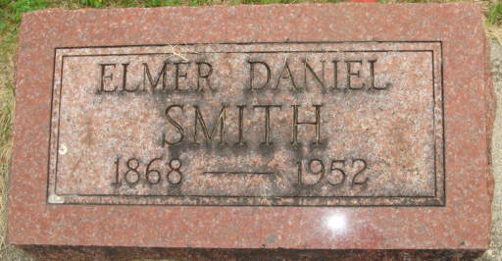
Photo by Alicia Kneuss

Danial Elmer Smith
in the Indiana, U.S., Death Certificates, 1899-2017
Name Daniel Elmer Smith
Gender Male
Race White
Marital Status Widowed
Age 83
Birth Date 4 Oct 1868
Birth Place Indiana
Death Date 31 May 1952
Death Place Fort Wayne, Allen, Indiana, USA
Death Registration Date 1952
Parents Unknown
Informant Dale Smith; Fort Wayne, Indiana
Burial June 3, 1952; Maplewood Cemetery; Decatur, Indiana

