Ellen Celesta (Shaffer) Smith
December 29, 1915 – April 15, 1997

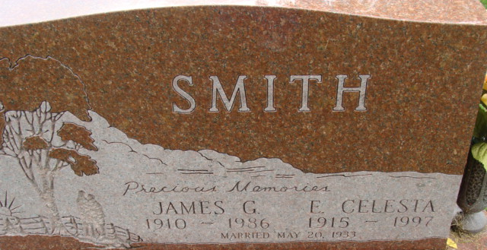
Photo by Alicia Kneuss

Ellen Celesta Smith
in the Indiana, U.S., Death Certificates, 1899-2017
Name Ellen Celesta Smith
[Ellen Celesta Shaffer]
Gender Female
Race White
Marital Status Widowed
Age 81
Birth Date 29 Dec 1915
Birth Place Silver Lake, Indiana
Death Date 15 Apr 1997; auto accident
Death Place Decatur, Adams, Indiana, USA
Death Registration Date 1997
Father Timothy Shaffer
Mother Lula Augenbaugh
Informant James A. Smith; son; Decatur, Indiana
Burial April 18, 1997; Decatur Cemetery; Decatur, Indiana

