Elizabeth (Kuntz) Smith
April 12, 1882 – February 26, 1971

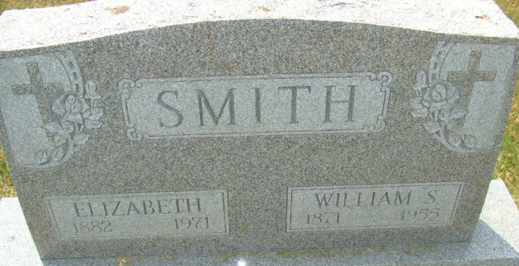
Photo by Alicia Kneuss

Elizabeth Smith Dies this Morning
Mrs. Elizabeth Smith, 88, a patient at the Cooper Rest Home, died at 6:50 a.m. today at the rest home, following an extended illness.
Born in Adams County April 12, 1882, she was a daughter of Mr. and Mrs. John Kuntz, and was married to William S. Smith Feb. 13, 1901. Her husband preceded her in death in 1955.
Surviving are five daughters, Mrs. Lillian Mettler of Bluffton, Mrs. Lydia Faulk of Montpelier, Mrs. Marie Slusher and Mrs. Doyle (Leona) Clevenger, both of Decatur and Mrs. DeLloyd (Jessie) Garwood of Brookville, O.; three sons, Clarence Smith of Oklahoma City, Okla., Herman Smith of Fort Wayne, and Max Smith of Gaithersburg, Md.; 3 grandchildren and 40 great grandchildren. One daughter, Maxine, one sister and two brothers are deceased.
Funeral rites will be conducted at 1:30 p.m. Monday at the Winteregg-Linn Funeral Home, with Rev. Gene Gardner officiating. Burial will be in the Decatur Cemetery. Friends may call at the funeral home after 7 p.m. Saturday until time of the services.
Decatur Daily Democrat, Adams County, Indiana
Friday, February 26, 1971

**
Indiana, U.S., Death Certificates, 1899-2011
Name: Elizabeth Smtih [Elizabeth Kuntz]
Gender: Female; Race: White
Age: 88
Marital status: Widowed
Birth Date: 12 Apr 1882
Birth Place: Ind
Death Date: 26 Feb 1971
Death Place: Decatur, Adams, Indiana, USA
Father: John Kuntz
Informant: Mrs. Doyle Clevenger; daughter; Decatur, Indiana
Burial: March 1, 1971; Decatur Cemetery; Decatur, Indiana

