Eliza Jane “Jennie” Smith
August 11, 1869 – December 17, 1939

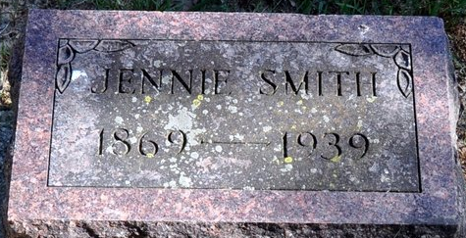
Photo by Deb Curry

DECATUR LADY DIES SUNDAY
Miss Eliza Jane Smith Dies Sunday at County Hospital
Miss Eliza Jane Smith, a life-long resident of the county, died Sunday afternoon at 1:30 o'clock in the Adams County Memorial Hospital. Death was attributed to complications (can't read)
The deceased was born in St. Mary's Township August 11, 1869, the daughter of Isaac and Margaret Smith. She was never married.
Survivors are a sister, Mrs. Lulu M. Walters of route 5 and a nephew Chalmer Walters who made his home with Miss Smith. One brother is deceased.
Funeral services will be held at 2:00 o'clock Tuesday afternoon at the Church of the Nazarene with the Rev. Paul Brandyberry officiating, and burial will be made in Decatur Cemetery. The family will (can't read the rest)

Decatur Daily Democrat, Adams County, Indiana
Monday, December 18, 1939

**
Indiana, U.S., Death Certificates, 1899-2017
Name Miss Eliza Jane Smith
Gender Female; Race White
Marital Status Single
Age 70 years, 4 months, 6 days
Birth Date abt 1869
Birth Place Adams County, Indiana
Death Date 17 Dec 1939
Death Place Decatur, Adams, Indiana, USA
Father Isaac Smith
Mother Margaret Cowen
Informant Chalmer L. Walters
Burial December 19, 1939; Decatur

