Electa L. (Macy) Smith
April 16, 1866 – February 16, 1938

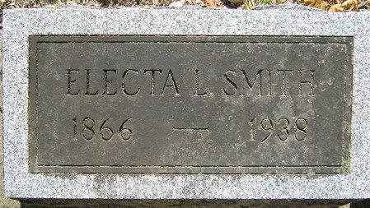
Photo by Alicia Kneuss

MRS. SMITH DIES AT MONROE - Mrs. W. S. Smith, 71 Dies After Long Illness
Mrs. Electa L. Smith 71, well know Monroe resident, died at her home Wednesday at noon. Death was caused by carcinoma.
The deceased was born in Farmland April 16, 1866 the daughter of Jethro and Mary Ann Macy.
She was a member of the Monroe M.E. Church and had lived in that town for the past 42 years.
Surviving besides the husband, W. S. Smith, are three children: Clarence R. Smith of Preble, Mrs. Anna G. Hendricks of Fort Wayne, Indiana and George O. Smith of Marysville, Ohio. A brother E.B. Macy of Decatur, two sisters, Mrs. Sadie Scherer of Fort Wayne, Mrs. Mary Lewellen of Monroe and five grandchildren also survive.
Funeral services will be held Friday afternoon at 2 o’clock with the Rev. E.S. Morford, pastor of the Monroe M.E. Church officiating. Burial will be made in the Decatur Cemetery.
Decatur Daily Democrat, Adams County, Indiana
February 16, 1938

