Eldora G. (Adams) Smith
October 3, 1904 – April 28, 1975

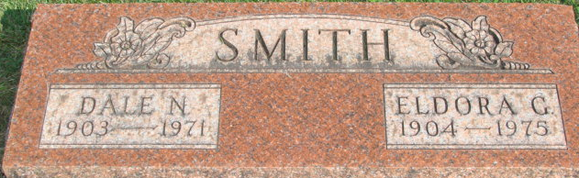
Photo by Alicia Kneuss

Eldora G. Smith
in the Indiana, U.S., Death Certificates, 1899-2017
Name Eldora G. Smith
[Eldora G. Adams]
Gender Female
Race White
Marital Status Widowed
Age 70
Birth Date 3 Oct 1904
Birth Place Indiana
Death Date 28 Apr 1975
Death Place Fort Wayne, Allen, Indiana, USA
Death Registration Date 1975
Father Francis M. Adams
Mother Jessie V. Wert
Informant Russell W. Adams; brother; Wolcottville, Indiana
Burial April 30, 1975; Decatur Cemetery; Decatur, Indiana

