Edith Murguerite (Swoveland) Smith
September 7, 1911 – April 11, 1958

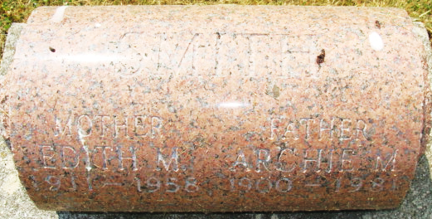
Photo by Alicia Kneuss

Edith Marguerite Swoveland from Riebe - Dellinger Family Tree
Spouse Archie Mcclelland Smith
Father William Elzy Swoveland
Mother Ordella "Della" Morehead
Children Wanda Belle
Birth 7 Sep 1911 Wren, Van Wert, Ohio, USA
Death 11 Apr 1958 Decatur, Adams, Indiana, USA
Residence 1957 Decatur, Adams, Indiana, USA

