E. Francile (Lower) Smith
August 6, 1905 – July 30, 1999

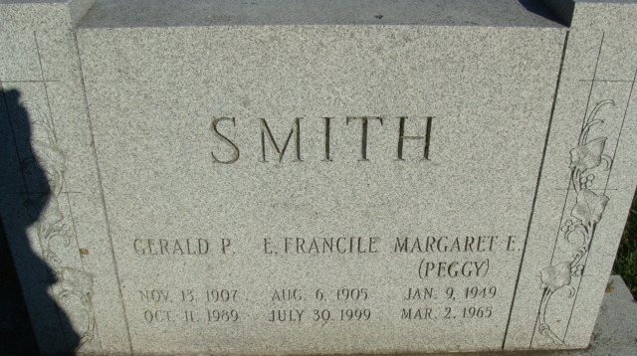
Photo by Alicia Kneuss

E. Francille Smith
in the Indiana, U.S., Death Certificates, 1899-2017

Name E. Francille Smith
[E. Francille Lower]
Gender Female
Race White
Marital Status Widowed
Age 93
Birth Date 6 Aug 1905
Birth Place Pittsburgh, Pennsylvania
Death Date 30 Jul 1999
Death Place Decatur, Adams, Indiana, USA
Death Registration Date 1999
Father Homer Lower
Mother Ada Archbold
Informant Mary Jane Allison; daughter; Decatur, Indiana
Burial August 2, 1999; Decatur Cemetery; Decatur, Indiana

