Dorothy May Smith
May 12, 1902 – July 2, 1961

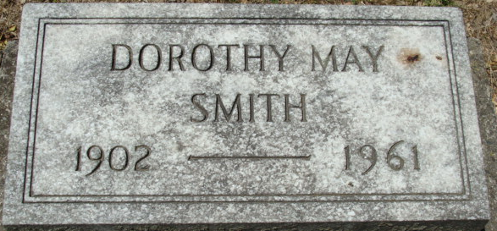
Photo by Alicia Kneuss

Dorothy M Smith
in the Indiana, U.S., Death Certificates, 1899-2017
Name Dorothy M Smith
Gender Female
Race White
Marital Status Never Married (Single)
Age 59
Birth Date 12 May 1902
Birth Place Decatur, Indiana
Death Date 2 Jul 1961
Death Place Fort Wayne, Allen, Indiana, USA
Death Registration Date 1961
Father Juge David E Smith
Mother Ethel Hale
Informant Byard H. Smith; brother
Burial July 5, 1961; Maplewood Cemetery; Decatur, Indiana

