Dorothy Ilene Smith
January 30, 1922 – January 30, 1922

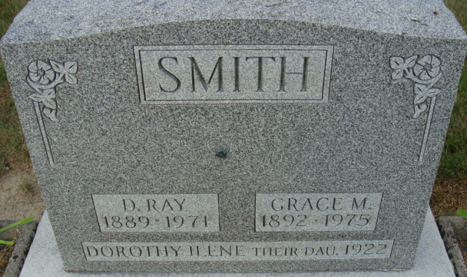
Photo by Alicia Kneuss

SMITH BABE FUNERAL TODAY

Private funeral services for Dorothy Ilene, infant daughter of Mr. and Mrs. Ray Smith, residing two miles south of this city, will be held this afternoon at 3 o’clock at home. The infant daughter was born at 2 o’clock this morning but lived only a half hour after birth.
The father, mother, two brothers and one sister survives.
The services were in charge of Rev. Haney of the Evangelical Church and interment was at the Decatur Cemetery.
Decatur Daily Democrat, Adams County, Indiana
Monday, January 30, 1922

**
Indiana, U.S., Death Certificates, 1899-2017
Name Dorothy Irene Smith
Gender Female
Race White
Age 2 minutes
Birth Date 30 Jan 1922
Birth Place Adams County, Indiana
Death Date 30 Jan 1922; premature
Death Place Decatur, Adams, Indiana, USA
Death Registration Date 1922
Father Ray D Smith
Mother Grace Zerkel
Informant Ray D. Smith; Decatur, Indiana
Burial January 30, 1922; Decatur Cemetery

