Daniel Ray Smith
October 12, 1889 – October 18, 1971

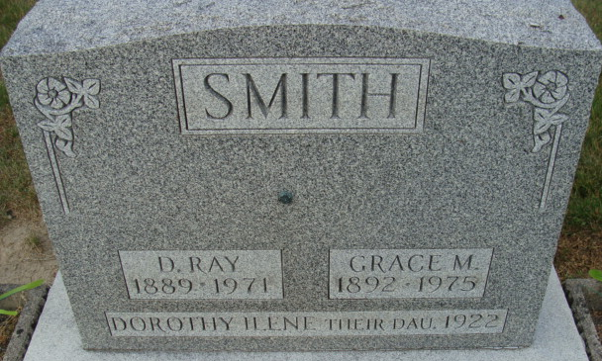
Photo by Alicia Kneuss

Daniel Ray Smith Dies at Hospital
Daniel Ray Smith, 82, of Decatur route 6, a longtime rural mail carrier, died at 11:25 a.m. Monday at the Adams County Memorial Hospital, following an extended illness.
Mr. Smith was a teacher in Washington Township Schools for five years, and then served as rural letter carrier out of the Decatur Post Office from 1915 until his retirement in 1957.
He was born in Adams County Oct. 12, 1889, a son of Harvey L. and Sarah Roe-Smith, and was married to Grace M. Zerkel July 27, 1910.
Mr. Smith was a member of St. Paul's Missionary Church.
Surviving are his wife; one daughter, Mrs. Austin (Ruth) Merriman of Monroe route 1; two sons, Clarence E. (John) Smith, and Lawrence R. (Pete) Smith, both of Decatur; one sister, Mrs. Osie Durr of Decatur route 6; two brothers, Perry Smith of Fort Wayne and Dee Smith of Ligonier; eight grandchildren, 19 great-grandchildren and one great-great-grandchild. A daughter, Dorothy; one sister and two brothers are deceased.
Funeral services will be conducted at 2 p.m. Thursday at the Winteregg-Linn Funeral Home, with Rev. Robert Welch officiating. Burial will be in the Decatur Cemetery. Friends may call at the funeral home after 7 p.m. today until time of the services.

Decatur Daily Democrat, Adams Co, Indiana
Tuesday, October 19, 1971

