Dale Nathaniel Smith
September 26, 1903 – July 10, 1971

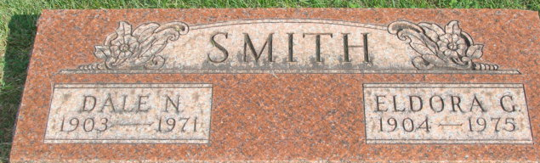
Photo by Alicia Kneuss

Dale N. Smith Taken by Death

Dale N. Smith, 68, of Wolcottville Route 1, died at 8 a.m. Saturday at McCray Memorial Hospital in Kendallville.
Mr. Smith was retired from Huser-Paul Co. in Fort Wayne, where he resided until 1966. He was a member of Eagles Aerie 248.
Surviving are his wife, Eldora; and a brother, Richard Smith of Marysville, Calif.
Services will be held at 1 p.m. Tuesday at D.O. McComb & Sons Funeral Home, Fort Wayne, with Rev. Benjamin Antle officiating. Burial will be in the Decatur Cemetery. Friends may call at the funeral home.

Decatur Daily Democrat, Adams County, Indiana
Monday, July 12, 1971

**
Indiana, U.S., Death Certificates, 1899-2011
Name: Dale N Smith
Gender: Male
Race: White
Age: 66
Marital status: Married
Birth Date: 26 Sep 1904
Birth Place: Indiana
Death Date: 10 Jul 1971
Death Place: Kendallville, Noble, Indiana, USA
Death Registration Date: 1971
Father: Elmer Smith
Mother: Lydia
Spouse: Eldora
Informant: Mrs. Eldora Smith; wife; Wolcottville, Indiana
Burial: July 13, 1971; Decatur Cemetery; Decatur, Indiana
**

Indiana Marriages, 1811-2019
Name Dale Nathanial Smith
Sex Male
Residence Place Fort Wayne, , Indiana
Birth Date 26 Sep 1901
Birthplace Decatur, , Indiana
Race White
Number of Previous Marriages first
Father's Name Elmer Smith
Father's Sex Male
Mother's Name Lydia
Mother's Sex Female
Spouse's Name Eldora Gertrude Adams
Spouse's Sex Female
Spouse's Residence Place Fort Wayne, , Indiana
Spouse's Birth Date 03 Oct 1904
Spouse's Birth Year (Estimated) 19
Spouse's Birthplace , , Indiana
Spouse's Race White
Spouse's Previous Marriage Number first
Spouse's Father's Name Frank Adams
Spouse's Father's Sex Male
Spouse's Mother's Name Jessie Wert
Officiator's Name Harry C Harman
Marriage Place Allen, Indiana
Marriage License Date 16 Jun 1923
Marriage License Place Allen, Indiana, United States
Event Type Marriage License
Page 496
Number of Images 1

