Clell Leland Smith
September 13, 1943 – September 14, 1943

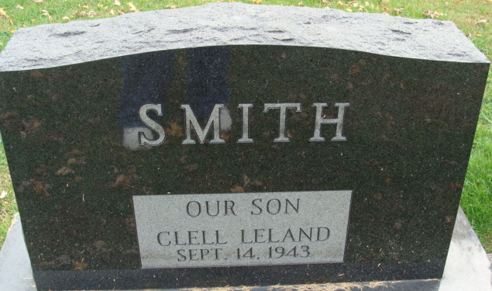
Photo by Alicia Kneuss

Infant Smith
in the Indiana, U.S., Death Certificates, 1899-2017
Name Infant Smith
Gender Male
Race White
Marital Status Single
Age 2 hours
Birth Date 13 Sep 1943
Birth Place Decatur, Adams County, Indiana
Death Date 14 Sep 1943; premature
Death Place Decatur, Adams, Indiana, USA
Death Registration Date 1943
Father Leland Smith
Mother Luetta Reffey
Informant Mrs. Leland Smith; Decatur, Indiana
Burial Not stated

