Clark W. Smith
February 2, 1916 – October 26, 2008

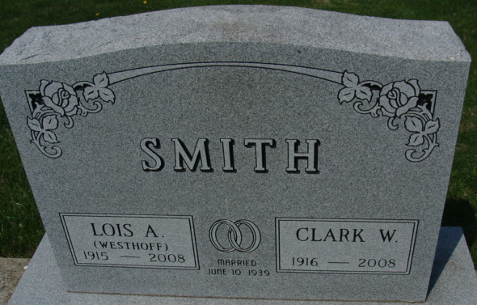
Photo by Alicia Kneuss

Clark W. "Tad" Smith, 92, of Indian Harbor Beach, Florida, a former Decatur resident, died on Sunday, October 26, 2008, at Wuesthoff Hospital in Melbourne, Florida.
He was born on February 2, 1916, in Adams County, Indiana, to the late Fred and Jean (Lutz) Smith. He married Lois A. Westhoff on June 10, 1939, and she passed away May 3, 2008.
Surviving is a daughter Mrs. Jerry (Deborah) McVicker of Indian Harbor Beach, Florida; five grandchildren; and five great-grandchildren. Preceding him in death were a daughter, Jeannie Biggs, and a brother, Lewis L. Smith.
Clark was a member of the First Presbyterian Church in Decatur. He was a local realtor and contractor for over 50 years with Ideal Realty; a 50-year member of the Decatur Lions Club; a member of Decatur Masonic Lodge No. 571, Scottish Rite Valley of Ft. Wayne, and Mizpah Shrine of Ft. Wayne; a member of the Adams-Jay County Board of Realtors; and a member of the Aircraft Owners' and Pilots' Association. He was an avid private pilot for over 40 years.
Funeral services will be held on Saturday, November 1, 2008, at 11 a.m. in Haggard and Sefton Funeral Home, Decatur, with calling one hour prior to services. Rev. Laura Sherwood will be officiating. A Masonic service will be held at 9:45 a.m. Saturday in the funeral home.
Burial will be in Decatur Cemetery.
Memorials are to the First Presbyterian Church.

Decatur Daily Democrat, Adams County, Indiana
Wednesday, October 29, 2008

