Clarence R. Smith
April 25, 1887 – October 13, 1971

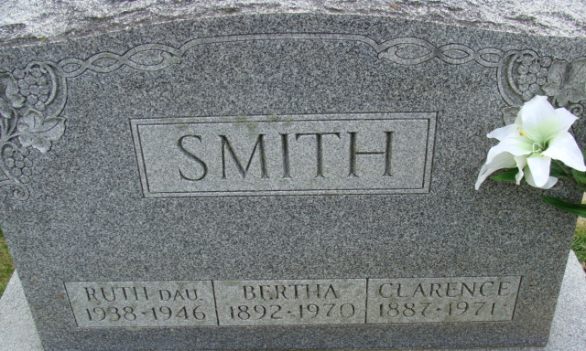
Photo by Alicia Kneuss

Clarence R. Smith Dies at Hospital
Clarence R. Smith, 84 of 209 North 15th Street, a former school teacher and banker, died at 4 p.m. Wednesday at the Veterans Hospital in Marion, following and extended illness.
A resident of Adams County for 78 years, he formerly taught school in the Monroe area, and for many years was associated with the Preble State Bank until it was closed.
He was born at Farmland April 25, 1887, to Wilford and Electa Macy-Smith, and was married to Bertha A. Fuhrman June 11, 1930. His wife preceded him in death Nov. 28, 1970.
Mr. Smith was a member of St. Mark's United Methodist Church, was a 55-year member of Decatur lodge 571 F&M, member of the Scottish Rite, York Rite, and American Legion.
Surviving are one sister, Mrs. Clyde (Anna Hendricks of Andrews, and one brother, George Smith of Ann Arbor, Mich. A daughter, Ruth, and a brother are deceased.
Funeral rites will be held at 2 p.m. Friday at the Winteregg-Linn Funeral Home, with Rev. Fuhrman Miller and Rev. Terry Neil Smith officiating. Burial will be in the Decatur Cemetery, with military rites at the graveside by the American Legion. Friends may call at the funeral home after 4 p.m. today until time of the services.

Decatur Daily Democrat, Adams County, Indiana
October 14, 1971

