Clarence E. “John” Smith
June 21, 1911 – November 9, 1977

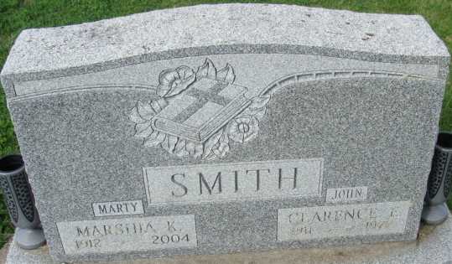
Photo by Alicia Kneuss

Clarence E Smith
in the Indiana, U.S., Death Certificates, 1899-2017
Name Clarence E Smith
Gender Male
Race White
Marital Status Married
Age 66
Birth Date 21 Jun 1911
Birth Place Indiana
Death Date 9 Nov 1977
Death Place Fort Wayne, Allen, Indiana, USA
Death Registration Date 1977
Father Daniel Ray Smith
Mother Grace M. Zerkel
Spouse Marshia Ohler
Informant Mrs. Clarence E. Smith; wife; Decatur, Indiana
Burial November 11, 1977; Decatur Cemetery; Decatur, Indiana

