Charlotte F. (Clark) Smith
May 13, 1912 – November 4, 1989

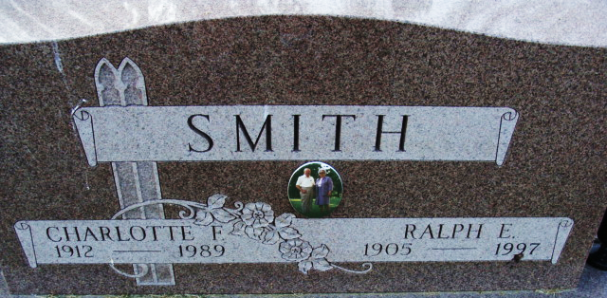
Photo by Alicia Kneuss

Charlotte F Smith
in the Indiana, U.S., Death Certificates, 1899-2017
Name Charlotte F Smith
[Charlotte F Clark]
Gender Female
Race White
Marital Status Married
Age 77
Birth Date 13 May 1912
Birth Place Clark County, Indiana
Death Date 4 Nov 1989
Death Place Decatur, Adams, Indiana, USA
Death Registration Date 1989
Father Jesse M Clark
Mother Fannie Morrison
Spouse Ralph E Smith, Sr.
Informant Ralph E. Smith, Sr.; husband; Decatur, Indiana
Burial November 7, 1989; Decatur Cemetery; Decatur, Indiana

