Charles F. Smith
September 8, 1882 – February 7, 1967

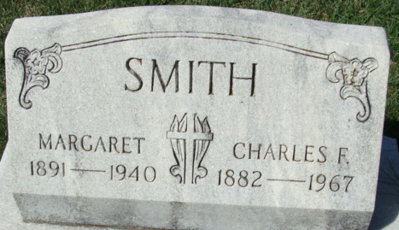
Photo by Alicia Kneuss

Charles F. Smith, 81, Sturgis resident for less than one year, died unexpectedly at 11:45 a.m. Tuesday, in his home at 205 1/2 Grove St. Prior to moving to Sturgis, Mr. Smith had been a resident of Decatur, Ind. for 42 years.
Mr. Smith was born at Markel, Ind. Sept. 8, 1882. He was married to Margaret Roop, in Decatur. She preceded him in death Apr. 15, 1941. He was a member of the Decatur First Methodist Church and was affiliated fraternally with the Sturgis Fraternal Order of Eagles and the Sturgis Loyal Order of Moose. He had been a carpenter and cabinet maker by trade.
Surviving are two sons, Charles D., of Sturgis, and Wendall, of Montmorency, Ind.; two daughters, Mrs. Ray (Thelma) Loveless, of Fort Wayne, and Mrs. Lester (Virginia) Diehl, of Middlebury, Ohio. Besides his wife, a daughter, Isabel Boitet, had preceded him in death in 1966. Surviving also are 15 grandchildren, seven great-grandchild-
ren, one great-great grandchild and a number of nieces and nephews.
Friends may call at the Foglesong Funeral Home, Wednesday evening, and at the Winteregg-Linn Funeral Home, Decatur beginning at 2 p.m. Thursday. Final rites will be held in the Winteregg-Linn Funeral Home at 1:30 p.m. Friday, with the Rev. Melvin Seegar, of the Decatur First Methodist Church, officiating. Internment will take place in the Decatur Cemetery.

Sturgis Daily Journal, Sturgis, Michigan
Wednesday, February 8, 1967
**
Michigan, U.S., Deaths and Burials Index, 1867-1995
Name Charles F. Smith
Birth Date 8 Sep 1882
Birth Place Indiana
Death Date 7 Feb 1967
Death Place Centreville, St. Joseph, Michigan
Death Age 84
Race White
Marital Status Widowed
Gender Male
FHL Film Number 1940926

