Charles B. Smith
November 20, 1872 – November 7, 1955

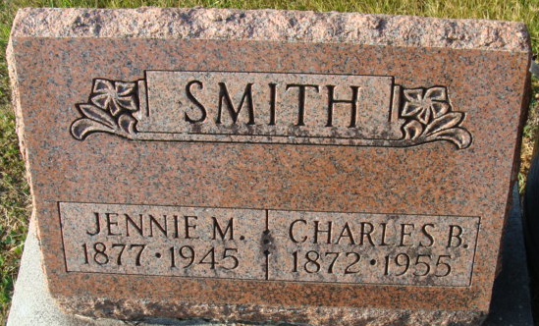
Photo by Alicia Kneuss

Charles B Smith
in the Indiana, U.S., Death Certificates, 1899-2017
Name Charles B Smith
Gender Male
Race White
Marital Status Widowed
Age 82
Birth Date 20 Nov 1872
Birth Place Indiana
Death Date 7 Nov 1955
Death Place Decatur, Adams, Indiana, USA
Death Registration Date 1955
Father Arnold Smith
Mother Maria
Informant Mrs. H. L. Koontz; Decatur, Indiana
Burial November 10, 1955; Decatur Cemetery; Decatur, Indiana

