Catherina (Warnick) Smith
September 23, 1875 – May 14, 1950

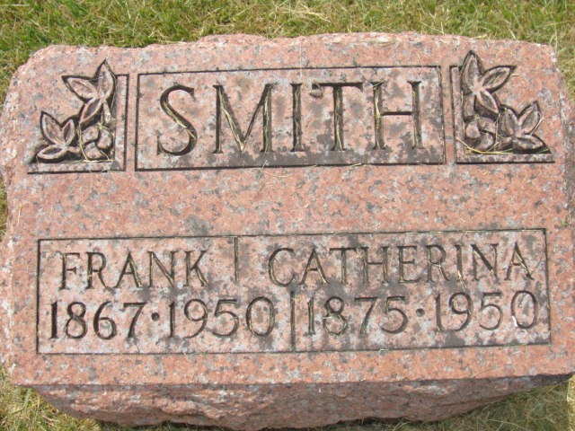
Photo by Alicia Kneuss

Katherine Smith
in the Indiana, U.S., Death Certificates, 1899-2017
Name Katherine Smith
[Katherine Warnick]
Gender Female
Race White
Marital Status Widowed
Age 74
Birth Date 23 Sep 1875
Birth Place Wabash, Indiana
Death Date 14 May 1950
Death Place Decatur, Adams, Indiana, USA
Death Registration Date 1950
Father Issiah Warnick
Mother Sarah Richardson
Informant Mrs. Faith Anderson; Decatur, Indiana
Burial May 17, 1950; Maplewood Cemetery; Decatur, Indiana

