Carl Henry Smith
June 3, 1900 – June 4, 1972

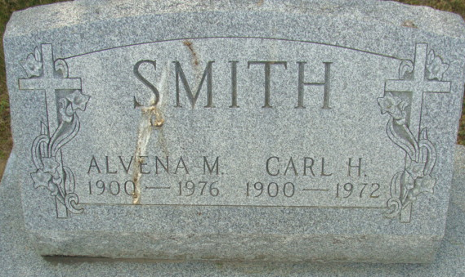
Photo by Alicia Kneuss

Carl Smith, 72, Dies at Hospital
Carl H. Smith, 72, of 121 North 10th Street, retired veteran employee of the Decatur General Electric Co. plant, died at 8 a.m. Sunday at the Lutheran Hospital in Fort Wayne, where he had been a patient for the past five weeks. He had been in failing health for some time. Mr. Smith was employed at the Decatur G.E. plant from 1920 until retiring in 1963, and was a foreman for many years.
Born at Celina, O. June 3, 1900, he was a son of John and Rosina Hoffman-Smith, and was married to Alvena Homeier May 26, 1926.
An active member of the Zion Lutheran church, he had served as a deacon, elder and trustee. He was a member of the G.E. Quarter Century club, and a member of the board of directors of the Adams county 4-H clubs.
Surviving are his wife; one sister, Mrs. William (Lucille) Goers of Worthington, O.; and a number of nieces and nephews.
Funeral services will be conducted at 3 p.m. Tuesday at the Zion Lutheran Church, with Rev. Richard C. Ludwig officiating. Burial will be in the Decatur Cemetery. Friends may call at the Zwick Funeral Home after 2 p.m. today. The body will lie in state at the church from 1 p.m. Tuesday until time of the services.

Decatur Daily Democrat, Adams County, Indiana
Monday, June 5, 1972

