Carl F. Smith
September 10, 1893 – January 31, 1914

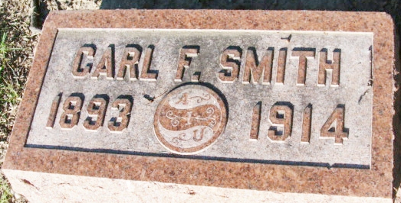
Photo by Alicia Kneuss

Carl F. Smith
in the Indiana, U.S., Death Certificates, 1899-2017
Name Carl F. Smith
Gender Male
Race White
Marital Status Single
Age 20
Birth Date 10 Sep 1893
Birth Place Indiana
Death Date 31 Jan 1914
Death Place Decatur, Adams, Indiana, USA
Death Registration Date 1910-1919
Father Jesse O. Smith
Mother Laura B. Magner
Informant Jesse O. Smith; Decatur, Indiana
Burial February 2, 1914; Decatur Cemetery

