Carl Smith
July 17, 1929 – April 24, 2011

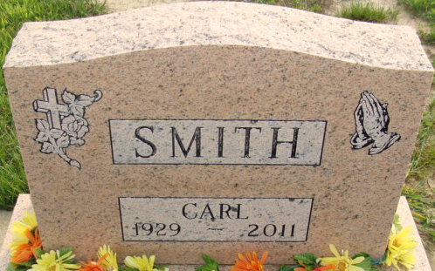
Photo by Alicia Kneuss

Carl Smith, 81, of Decatur, Indiana died on Sunday, April 24, 2011 at The Village of Heritage in Monroeville. Carl was the son of the late Charles and Elizabeth (Zueber) Smith. He was born July 17, 1929 in Haviland, Ohio.
He is preceded in death by two sisters and four brothers. Carl attended First United Methodist Church in Decatur. He also had worked for Bi-County Services in Bluffton, Indiana.
A Graveside service will be on Wednesday, April 27, 2011 at 11:00 a.m. at the Decatur Cemetery with calling from 10:00-10:45 a.m. at Haggard-Sefton & Hirschy Funeral Home. Officiating will be Rev. Loren Felabom.
Memorials are to The Village of Heritage.

Haggard & Sefton Funeral Home, Adams County, Indiana
April 25, 2011

**
Indiana, U.S., Death Certificates, 1899-2017
Name Carl Smith
Gender Male
Race White
Marital Status Never Married (Single)
Age 81
Birth Date 17 Jul 1929
Birth Place Haviland, Ohio
Death Date 24 Apr 2011
Death Place Monroeville, Allen, Indiana, USA
Death Registration Date 2011
Father Charles Smith
Mother Elizabeth Ann Zueber
Informant Jennie Minnich; Caregiver; Monroeville, Indiana
Burial Decatur Cemetery; Decatur, Indiana

