Burton L. Smith
April 27, 1896 – October 11, 1955

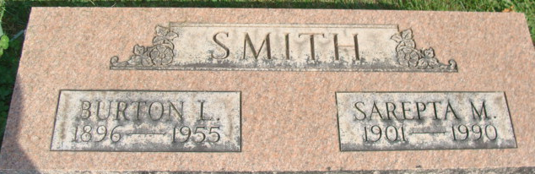
Photo by Alicia Kneuss

Burton L Smith
in the Indiana, U.S., Death Certificates, 1899-2017
Name Burton L Smith
Gender Male
Race White
Marital Status Married
Age 59
Birth Date 27 April 1896
Birth Place Indiana
Death Date 11 Oct 1955
Death Place Fort Wayne, Allen, Indiana, USA
Death Registration Date 1955
Father Elmer Smith
Mother Lydia
Informant Sarepta Smith; Fort Wayne, Indiana
Burial October 14, 1955; Decatur Cemetery; Decatur, Indiana

