Brock Allen Smith
August 22, 1978 – October 15, 1978

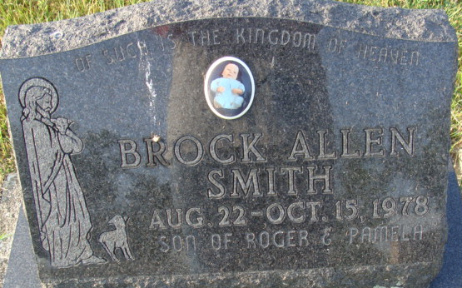
Photo by Alicia Kneuss

Brock A Smith
in the Indiana, U.S., Death Certificates, 1899-2017
Name Brock A Smith
Gender Male
Race White
Marital Status Never Married (Single)
Age 1/12
Birth Date 22 Aug 1978
Birth Place Indiana
Death Date 15 Oct 1978; auto accident
Death Place Indiana, Marion, Indiana, USA
Death Registration Date 1978
Father Roger Smith
Mother Pamela Payner
Informant Roger Smith; Monroe, Indiana
Burial October 17, 1978; Decatur Cemetery; Decatur, Indiana

