Bertha M. (Hill) Smith
May 21, 1927 – July 31, 2013

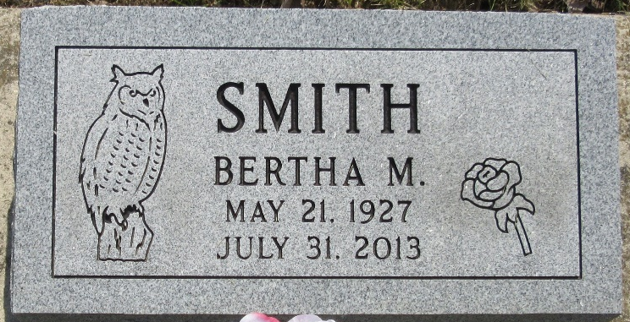
Photo by PLS

Bertha M. Smith, 86, of Bluffton, passed away at 7:01 a.m. Wednesday, July 31, 2013 at Meadowvale Health & Rehabilitation Center. Bertha was born in Michigan on May 21, 1927 to Levi and Gladys (Spade) Hill. Bertha married Archie Smith in Decatur, Indiana on September 4, 1965 and he preceded her in death.
Bertha was an "In Home Caregiver" for several people over the years. Bertha loved music and enjoyed playing bingo. She collected owls and music boxes.
She is survived by four sons, Danny Dishong, Larry Dishong, Rex Dishong, Lawrence Dishong, three daughters, Shirley Bradley, Mary Nutt, Dianna Heiniger, ten grandchildren, twelve great-grandchildren two great-great-grandchildren.
In addition to her parents and husband, she was preceded in death by two sisters, Dorothy Dishong, Mary Millington-Pratt and by a brother, Edward Hill.
Calling hours are 9:00 to 11:00 a.m. Friday, August 2, 2013 at Thoma/Rich, Chaney & Lemler Funeral Home. Funeral service is at 11:00 a.m. Friday at the funeral home with Pastor Neil Ainslie officiating. Burial will be in the Decatur Cemetery.
Preferred memorials are to the family.

Thoma/Rich Funeral Home, Wells County, Indiana
August 1, 2013

