Bertha A. (Fuhrman) Smith
October 30, 1892 – November 28, 1970

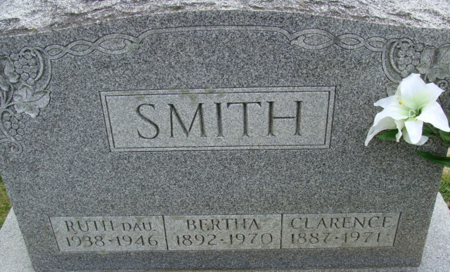
Photo by Mike Horn

Bertha Smith Dies After Long Illness

Mrs. Bertha A. Smith, 78, wife of Clarence R. Smith of 209 North 17th Street, died at 10:45 p.m. Saturday at the Lakeview Nursing Home, following an extended illness.
Born in Root Township Oct. 30, 1892, she was a daughter of John A. and Emma Dutcher-Fuhrman and was married to Clarence R. Smith June 11, 1930.
Mrs. Smith was a member of St. Mark’s United Methodist Church, The Esther Circle of the church, and the Historical Club.
Surviving is her husband; one brother, Earl C. Fuhrman of Decatur; and one sister, Mrs. Elsie Newhard of Decatur. A daughter, Ruth, one sister and four brothers are deceased.
Funeral services will be conducted at 2 p.m. Tuesday at the Winteregg-Linn Funeral Home, with Rev. Fuhrman Miller officiating. Burial will be in the Decatur Cemetery. Friends may call at the funeral home after 2 p.m. today until time of the services.

Decatur Daily Democrat, Adams County, Indiana
Monday, November 30, 1970

