Benjamin S. Smith
July 25, 1901 – July 6, 1914

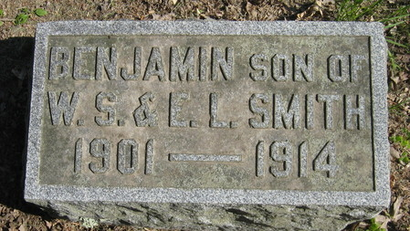
Photo by Mike Horn

CAPS DISCHARGED - BOY IS KILLED - PARALYSIS OF THE HEART CAUSED BOY’S DEATH AT MONROE TODAY
Bennie Smith, 13-year-old son of W.S. Smith of Monroe, died suddenly at noon today when the explosion of torpedo caps in his waist pocket caused paralysis of the heart. The boy was wrestling with another playmate, and this caused the explosion of ten or twelve of the small caps in his pocket. He was dead when people rushed to his aid and the doctors say the heart was paralyzed.

Bluffton Evening Banner, Wells County, Indiana
Monday, July 6, 1914.

**
Indiana, U.S., Death Certificates, 1899-2017
Name Benjamin S Smith
Gender Male
Race White
Marital Status Single
Age 12
Birth Date 25 Jul 1901
Birth Place Monroe, Indiana
Death Date 6 Jul 1914
Death Place Monroe, Adams, Indiana, USA
Death Registration Date 1910-1919
Father Wm S. Smith
Mother Elekta Macy
Informant W. S. Smith; Monroe, Indiana
Burial July 8, 1914; Decatur Cemetery

