Augustus P. Smith
1830 – June 28, 1889

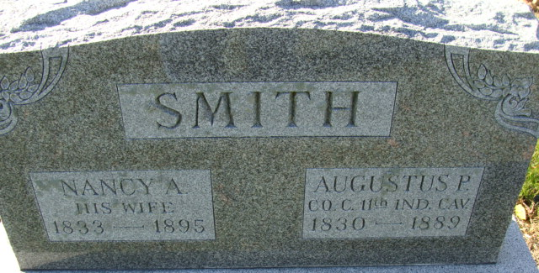
Photo by Alicia Kneuss

Augustus P Smith
in the U.S., Civil War Draft Registrations Records, 1863-1865
Name Augustus P Smith
Marital Status Married
Race White
Age 33
Birth Year abt 1830
Birth Place Ohio
Residence Date 1 Jul 1863
Residence Place Adams, Indiana, USA
Congressional District 11th; Class 1
Series Number Nm-65, Entry 172
Description Class 1, O-S, Volume 2 of 6
**
Indiana, U.S., Marriages, 1810-2001
Name Augustine Smith
Gender Male
Event Type Marriage Registration (Marriage)
Marriage Date 27 Dec 1853
Marriage Place Indiana, United States
Spouse Nancy Smith
Officiator Samuel L Rugg
Page 148
FHL Film Number 002321470
**

Augustus P Smith from tree Case Family Tree
Birth 1831 Ohio, USA
Marriage 29 Dec 1853 Adams, Indiana, USA
Residence 1880 Decatur, Adams, Indiana, USA
Death 28 Jun 1889 Decatur, Adams, Indiana, USA
Mother Elizabeth (Born 1793)
Spouse Nancy Ann Smith (1833-1895)

