Ashley Rene Smith
February 11, 1984 – February 12, 1984

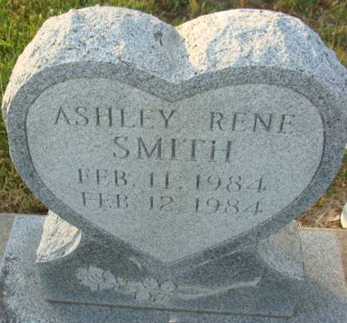
Photo by Alicia Kneuss

Ashley Ranae Smith
in the Indiana, U.S., Death Certificates, 1899-2017
Name Ashley Ranae Smith
Gender Female
Race White
Marital Status Never Married (Single)
Age 11 hours
Birth Date 11 Feb 1984
Birth Place Indiana
Death Date 12 Feb 1984
Death Place Fort Wayne, Allen, Indiana, USA
Death Registration Date 1984
Father Roger W. Smith
Mother Pamela J. Painter
Informant Roger Smith; father; Monroe, Indiana
Burial February 14, 1984; Decatur Cemetery; Decatur, Indiana

