Archie M. Smith
September 2, 1900 – December 19, 1981

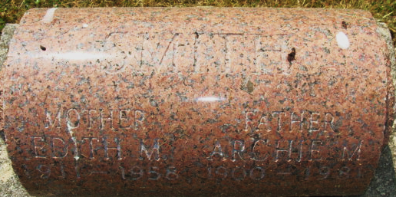
Photo by Alicia Kneuss

Archie M. Smith
in the Indiana, U.S., Death Certificates, 1899-2017
Name Archie M. Smith
Gender Male
Race White
Marital Status Widowed
Age 81
Birth Date 2 Sep 1900
Birth Place Indiana
Death Date 19 Dec 1981
Death Place Decatur, Adams, Indiana, USA
Death Registration Date 1981
Father John Smith
Mother Cora Belle Gessinger
Informant Larry Smith; Decatur, Indiana
Burial December 21, 1981; Decatur Cemetery; Decatur, Indiana

