Annabelle (Yike) Smith
November 15, 1908 – March 29, 2003

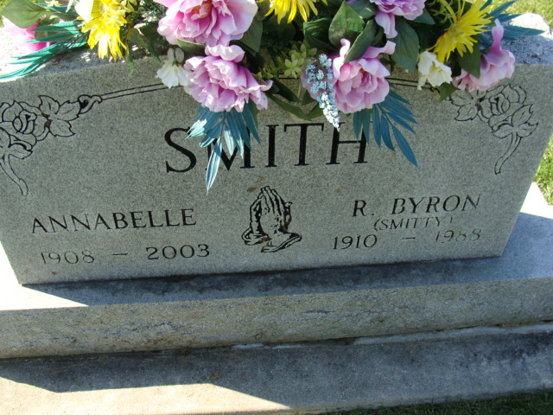
Photo by Alicia Kneuss

Annabelle Smith
in the Indiana, U.S., Death Certificates, 1899-2017

Name Annabelle Smith
[Annabelle Yike]
Gender Female
Race White
Marital Status Widowed
Age 94
Birth Date 15 Nov 1908
Birth Place Rochester, Indiana
Death Date 29 Mar 2003
Death Place Monroeville, Allen, Indiana, USA
Death Registration Date 2003
Father John L Yike
Mother Orpha C Musselman
Informant Mrs. Joyce A. Hahn; daughter; Monroeville, Indiana
Burial April 2, 2003; Decatur Cemetery; Decatur, Indiana

