Amy (Andrews) Smith
August 23, 1892 – November 12, 1915

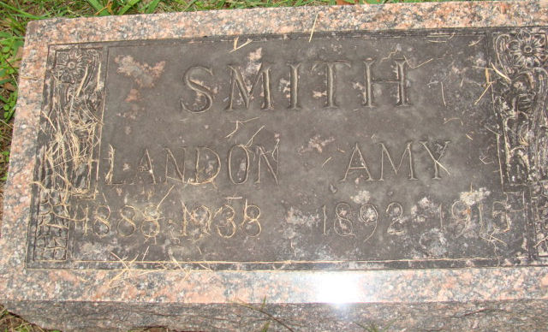
Photo by Alicia Kneuss

Amy Smith
in the Indiana, U.S., Death Certificates, 1899-2017
Name Amy Smith
[Amy Andrews]
Gender Female
Race White
Marital Status Married
Age 23
Birth Date 23 Aug 1892
Birth Place Adams County
Death Date 12 Nov 1915; tuberculosis
Death Place Decatur, Indiana, USA
Death Registration Date 1910-1919
Father Lewis M Andrews
Mother Malinda
Spouse Landon Smith
Informant Mrs. B. Carson
Burial November 14, 1915; Decatur Cemetery

