Amos Z. Smith
January 4, 1873 – July 23, 1936

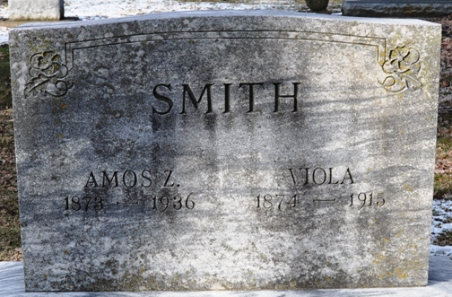
Photo by Deb Curry

DEATH TAKES AMOS SMITH
Prominent Retired Farmer Dies at Home in Decatur
Decatur, July 27 – Amos Z. Smith, 63, retired farmer and lifelong resident of Adams County, died at his home on West Jefferson Street Thursday night at 6:30 o'clock. Death was due to Parkinson's disease.
Mr. Smith was a member of the Methodist Episcopal Church at Pleasant Mills and of the Gleaners' lodge.
He was born in Adams County on January 4, 1873, a son of Joseph and Catherine Smith. He was married to Mary V. Smith, who preceded him in death.

Adams County Historical Museum, Adams County, Indiana
1936 Scrapbook, image 99
Handwritten date: Monday, 1936

**
Indiana, U.S., Death Certificates, 1899-2017
Name Amos Z Smith
Gender Male
Race White
Marital Status Widowed
Age 63
Birth Date 4 Jan 1873
Birth Place Adams County, Indiana
Death Date 23 Jul 1936
Death Place Decatur, Adams, Indiana, USA
Death Registration Date 1936
Father Joseph W Smith
Mother Catherine Gulick
Spouse Mary V
Informant Lowell J. Smith; Decatur, Indiana
Burial July 26, 1936; Decatur Cemetery

