Alvena M. (Homeier) Smith
April 19, 1900 – April 29, 1976

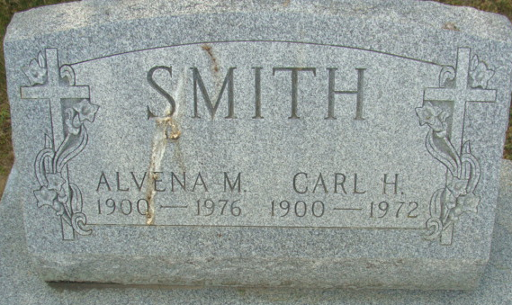
Photo by Alicia Kneuss

Alvena M Smith
in the Indiana, U.S., Death Certificates, 1899-2017
Name Alvena M Smith
[Alvena M Homeier]
Gender Female
Race White
Marital Status Widowed
Age 76
Birth Date 19 Apr 1900
Birth Place Indiana
Death Date 29 Apr 1976
Death Place Fort Wayne, Allen, Indiana, USA
Death Registration Date 1976
Father Frederick Homeier
Mother Hanna Stodtman
Informant Mrs. Louie Jacobs; friend; Decatur, Indiana
Burial May 2, 1976; Decatur Cemetery; Decatur, Indiana

