Alice (Norris) Smith
July 14, 1899 – July 22, 1983

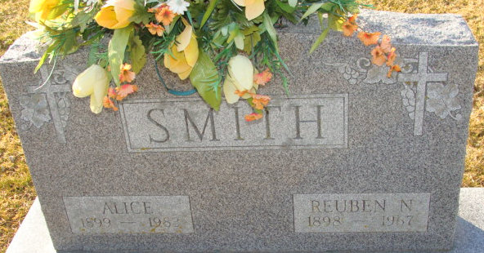
Photo by Alicia Kneuss

Alice Smith
in the Indiana, U.S., Death Certificates, 1899-2017
Name Alice Smith
[Alice Norris]
Gender Female
Race White
Marital Status Widowed
Age 84
Birth Date 14 Jul 1899
Birth Place Ohio
Death Date 22 Jul 1983
Death Place Decatur, Adams, Indiana, USA
Death Registration Date 1983
Father Marcellus Norris
Mother Chloe Detrick
Informant Dorothy Call; daughter; Decatur, Indiana
Burial July 25, 1983; Decatur Cemetery; Decatur, Indiana

