Alice E. (Callow) Smith
February 2, 1859 – September 12, 1944

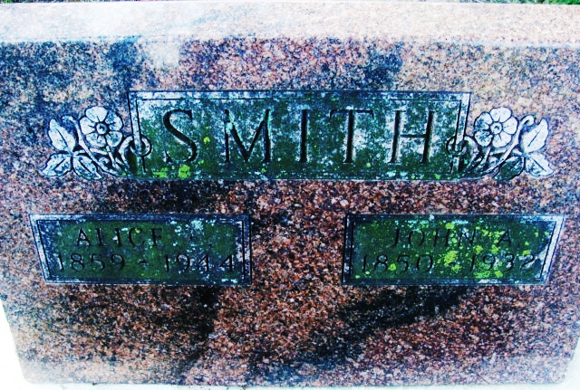
Photo by Alicia Kneuss

Mrs Alice Smith
in the Indiana, U.S., Death Certificates, 1899-2017

Name Mrs Alice Smith
[Mrs Alice Callow]
Gender Female
Race White
Marital Status Widowed
Age 85
Birth Date 2 Feb 1859
Birth Place Crestline, Ohio
Death Date 12 Sep 1944
Death Place Fort Wayne, Allen, Indiana, USA
Death Registration Date 1944
Father William Callow
Mother Alice
Spouse John A Smith
Informant Fred Bontell; Fort Wayne, Indiana
Burial September 15, 1944; Decatur Cemetery; Decatur, Indiana

