Alfred J. Smith
October 3, 1897 – May 15, 1971

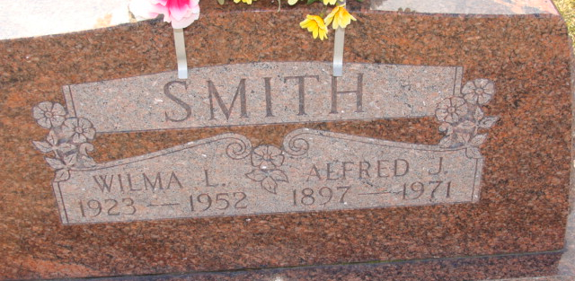
Photo by Alicia Kneuss

Alfred J Smith
in the Indiana, U.S., Death Certificates, 1899-2017
Name Alfred J Smith
Gender Male
Race White
Marital Status Widowed
Age 73
Birth Date 3 Oct 1897
Birth Place Indiana
Death Date 15 May 1971
Death Place Decatur, Adams, Indiana, USA
Death Registration Date 1971
Parents Not named
Informant Mrs. Eugene (Sharon) Everett; daughter; Monroe, Indiana
Burial May 18, 1971; Decatur Cemetery; Decatur, Indiana

**
Indiana, U.S., Marriage Certificates, 1960-2012
Name Alfred J Smith
Marriage Age 49
Birth Date 3 Oct 1897
Marriage Date 3 Feb 1947
Marriage Place St. Joseph, Indiana, USA
Father John Smith
Mother Elizabeth Nieswander
Certifier Dwight L Matthews

