Wilma I. (Miller) Small
May 18, 1917 – February 23, 2003

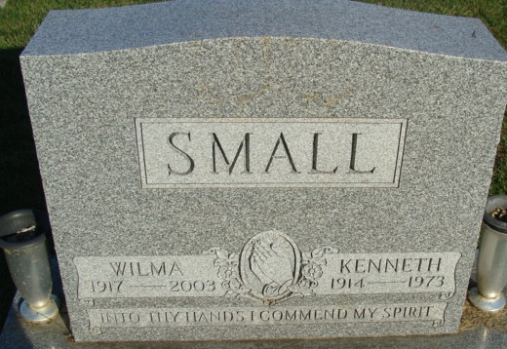
Photo by Alicia Kneuss

Wilma I Small
in the Indiana, U.S., Death Certificates, 1899-2017

Name Wilma I Small
[Wilma I Miller]
Gender Female
Race White
Marital Status Widowed
Age 85
Birth Date 18 May 1917
Birth Place Ohio
Death Date 23 Feb 2003
Death Place Decatur, Adams, Indiana, USA
Death Registration Date 2003
Father Arthur B Miller
Mother Lola C Myers
Informant Donna Marbach; daughter; Decatur, Indiana
Burial February 27, 2003; Decatur Cemetery; Decatur, Indiana

