Kenneth E. Small
August 30, 1914 – February 8, 1973

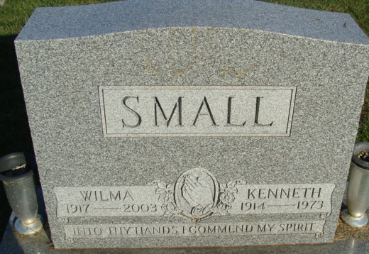
Photo by Alicia Kneuss

Kenneth E. Small Dies at Hospital
Kenneth E. Small, 58, of 608 Indiana Street, a retired employee of the Decatur General Electric plant, died at 8:25 p.m. Thursday at the Adams County Memorial Hospital, where he had been a patient three days. He retired from the G.E. after 22 years of service, and was a member of the Decatur men’s bowling league.
Born in Sturgis, Mich., on August 30, 1914, he was the son of John and Violet Stetler-Small, and was married to Wilma Miller on October 22, 1938.
Surviving are the wife; four daughters, Mrs. Verlin (Norma) Strickland and Mrs. Darrell (Barbara) Vardamen, both of Marion; Mrs. Richard (Donna) Marbach of route 5; and Mrs. Wendell (Deanna) Capes of Hendersonville, N.C.; one step-sister, Mrs. Glen (Lola) Egley of route 2, Ohio City, O.; one half-sister, Mrs. Frank (Gladys) Stetler of Fort Wayne; and Lleroyd [sic] (Bud) Stetler of Millbrae, California; one half-brother, LaVerne Stetler of Decatur; and 14 grandchildren.
Funeral services will be held Saturday at 3:30 p.m. at the Zwick Funeral Home with Rev. Roy Mickley officiating. Burial will be in the Decatur Cemetery. Friends may call at the funeral home after 7 p.m. tonight and until time of the services.

Decatur Daily Democrat, Adams County, Indiana
Friday February 9, 1973

