Sandra J. (Deere) Slusher
1951 -

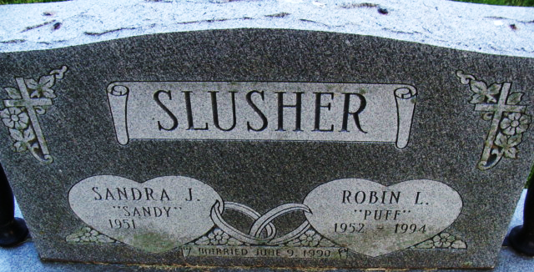
Photo by Alicia Kneuss

