Robin Lee “Puff” Slusher
May 22, 1952 – June 2, 1994

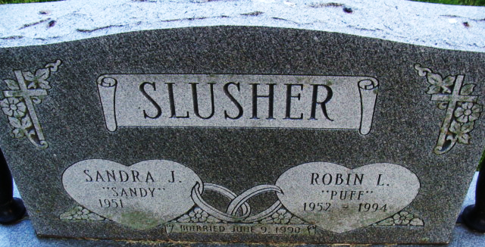
Photo by Alicia Kneuss

Robin Lee Slusher
in the Indiana, U.S., Death Certificates, 1899-2017
Name Robin Lee Slusher
Gender Male
Race White
Marital Status Married
Age 42
Birth Date 22 May 1952
Birth Place Adams County, Indiana
Death Date 2 Jun 1994
Death Place Decatur, Adams, Indiana, USA
Death Registration Date 1994
Father William Slusher
Mother Mabel M Rupert
Spouse Sandra Deere
Informant Sandra Slusher; wife; Decatur, Indiana
Burial June 4, 1994; Decatur Cemetery; Decatur, Indiana

