Ivan Eugene Slusher
January 13, 1925 – August 10, 1929

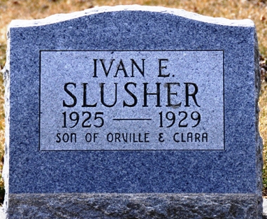
Photo by Deb Curry

Ivan Eugene Slusher
in the Indiana, U.S., Death Certificates, 1899-2017
Name Ivan Eugene Slusher
Gender Male
Race White
Marital Status Single
Age 4
Birth Date 13 Jan 1925
Birth Place Decatur, Indiana
Death Date 10 Aug 1929
Death Place Decatur, Adams, Indiana, USA
Death Registration Date 1929
Father Orval Slusher
Mother Clara Van Camp
Informant Orval Slusher; Decatur, Indiana
Burial August 12, 1929; Decatur City Cemetery

