Jordan Daniel Sloffer
February 25, 1987 – September 21, 2008

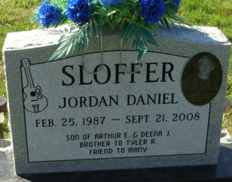
Photo by Alicia Kneuss

Jordan D. Sloffer, 21 years old, of Decatur, passed away on Sunday, September 21, 2008 at his residence. He was born on February 25, 1987, in Fort Wayne, the son of Arthur and Deena (Boggs) Sloffer.
Jordan was a C. N. C. operator at Bluffton Motor Works, where he had been employed for the past year and a half.
Surviving are his parents, Arthur and Deena Sloffer of Decatur; a brother, Tyler R. Sloffer of Decatur; and his maternal grandparents, Ray and Betty Boggs of Churubusco, Indiana. Preceding Jordan in death were his paternal grandparents, Everett and Dorothy Sloffer.
Funeral services will be held at 10:30 a.m. on Thursday, September 25, 2008, in Zwick and Jahn Funeral Home, Decatur. Friends will be received from 1-4 p.m. and 5 - 8 p.m. on Wednesday, September 24, in Zwick and Jahn Funeral Home.
Preferred memorials are to Teen Challenge.

Decatur Daily Democrat, Adams County, Indiana
Tuesday, September 23, 2008

**
Indiana, U.S., Death Certificates, 1899-2017
Name Jordan D Sloffer
Gender Male; Race White
Marital Status Never Married (Single)
Age 21
Birth Date 25 Feb 1987
Birth Place Fort Wayne, Indiana
Death Date 21 Sep 2008
Death Place Decatur, Adams, Indiana, USA
Death Registration Date 2008
Father Arthur Sloffer
Mother Deena Boggs
Informant Arthur Sloffer; father; Decatur, Indiana
Burial Decatur Cemetery; Decatur, Indiana

