Erma L. (Morrison) Sliger
June 22, 1930 – July 7, 2012

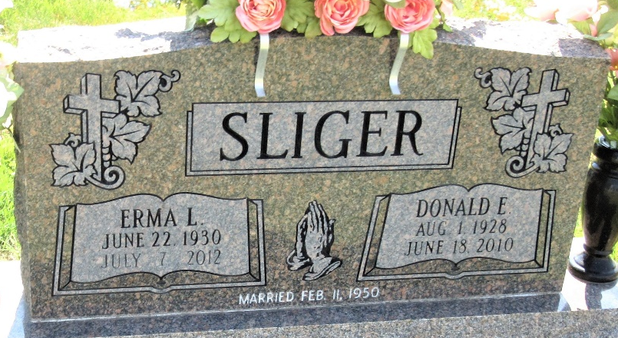
Photo by PLS

Erma L. Sliger, 82, of Decatur, passed away at Woodcrest Nursing Center in Decatur, Indiana. Erma was born on June 22, 1930 to the late Frank and Lillian (Hunter) Morrison in Rocky Point, Missouri. On February 11, 1950 she married Donald E. Sliger, he passed away on June 18, 2010.
Erma was a member of First Baptist Church in Decatur. She taught Jr. Girls Sunday School and Child Evangelism for many years. She worked as a secretary for the U.S. Government Farmers Home Administration and a homemaker.
She is survived by one son Stephen (Elaine) Sliger of Detroit, MI., two daughters Kathie Amstutz of Saginaw, MI., and Mrs. Karen (David) Huckeba of Atlanta, GA., 8 grandchildren and 10 great grandchildren. She was also preceded in death by 3 brothers Lawrence, Leonard, and Glenn Morrison and a sister Lois Klunder.
Visitation will be from 5:00 – 8:00 p.m. on Tuesday, July 10, 2012 at Haggard-Sefton & Hirschy Funeral Home. Funeral Service will be held at 10:00 a.m. on Wednesday, July 11, 2012 at HaggardSefton & Hirschy Funeral Home. Officiating will be Pastor Whitney West and Chaplain John Follett. Burial will take place in the Decatur Cemetery.
Memorials may be made to First Baptist Church.

Haggard & Sefton Funeral Home, Adams County, Indiana
July 8, 2012

**
U.S., Obituary Collection, 1930-Current
Name Erma L. Sliger
[Erma L. Morrison]
Gender Female
Death Age 82
Birth Date 22 Jun 1930
Birth Place Rocky Point, Missouri
Marriage Date 11 Feb 1950
Residence Place Decatur
Death Date July 7, 2012
Burial Date 11 Jul 2012
Father Frank Morrison
Mother Lillian Morrison
Spouse Donald E. Sliger
Child Kathie Amstutz, Stephen Sliger, Karen Huckeba
Siblings Leonard, Lawrence, Lois Klunder

