Donald E. Sliger
August 1, 1928 – June 18, 2010

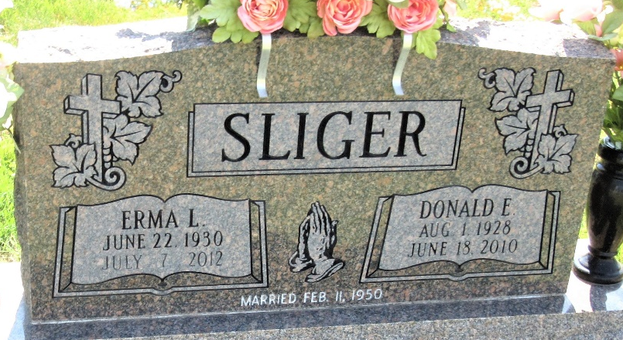
Photo by PLS

Donald E. Sliger, 81, of Decatur died at his residence Friday, June 18, 2010. He was born on August 1, 1928 in Wells County, Indiana to the late Dwight E. and Nellie (Huss) Sliger. He married Erma L. Morrison on February 11, 1960.
Donald was a member of the First Baptist Church in Decatur and was a former Sunday school teacher. He worked for Navistar in the Inspection/Quality Control area for 34 years and retired in 1981.
Survivors are his wife Erma L. Sliger of Decatur, IN; a son Stephen (Elaine) Sliger of Detroit, MI; two daughters Kathie Amstutz of Saginaw, MI and Mrs. Karen (David) Huckeba of Atlanta, GA; two brothers Larry Sliger of Bluffton, IN and Fred (Sue) Sliger of Zanesville, IN; two sisters Wanda Bunch of Bluffton, IN and Mrs. Lou (Carolyn) Vangordon of Hartford City, IN; eight grandchildren and six great grandchildren. He is preceded in death by two sisters Alice May Bunch and Louise Robles.
Visitation is from 1-5 pm Sunday, June 20, 2010 at Haggard and Sefton Funeral Home. Funeral Service will be at 2:00 pm Monday, June 21, 2010 also at the Funeral Home. Rev. John Follett will be officiating and burial will be in Decatur Cemetery.
Memorials are to First Baptist Church.

Haggard & Sefton Funeral Home, Adams County, Indiana
June 19, 2010

